TIPS FOR LOCALIZING
***FOR MARKETS: Consider swapping out one of the destinations for a region within your own market that has its own destination which is considered to be ideal for ‘Baby Boomers’ seeking adventure travel. For relevant data, please check the All Survey Document on Box.

The following Booking.com business priorities are reflected in this pitch:
- Connected Trip (attractions)
- Homes
- US

Please check that these Homes and Attractions are still available to book within the 90-day period.

As always, please share content with your day-to-day Booking.com contact for final approval***

Booking.com Spotlights Thrill-Seeking Destinations for Baby Boomers Ready to Embrace Adventure

Baby Boomers are redefining what it means to stay active and fearless, seeking experiences that are every bit as daring as they are rewarding. With nearly a quarter (23%)* of Boomers (those born between 1946 and 1964) interested in vacations that involve adventure and 23%* keen to step outside their comfort zones and rediscover the carefree spirit of youth, Booking.com is spotlighting destinations where these travelers can unleash their adventurous spirit. For some, thrill-seeking means paragliding above rugged coastlines or exploring ancient caves. For others, it’s about immersing in new cultures, savoring once-in-a-lifetime culinary experiences, or exploring landscapes rich in history and heritage. From helicopter rides and hidden wine valleys to midnight stargazing, when it comes to exploring the world, the thrill of exploration knows no age.

Phong Nha, Vietnam
In the heart of Phong Nha-Kẻ Bàng National Park, a UNESCO World Heritage site, adventure is written into the limestone landscape. For those craving discovery, this park’s caves offer journeys that balance excitement with accessibility. Paradise Cave reveals soaring chambers and glittering stone formations, with walkways that make it possible to venture far into this subterranean world without difficulty. Phong Nha Cave heightens the thrill as travelers are able to glide by wooden boats over turquoise waters, venturing into echoing passageways where each reveals a hidden wonder. For those eager to embrace a once-in-alifetime adventure, expeditions into Hang Son Doong, the largest cave on Earth, delivers the ultimate experience; trekking through vast caverns and camping beneath an underground jungle unlike anything on this planet. Whether by boat, on foot, or on a multi-day expedition, Phong Nha’s caves prove that adventure doesn’t have an age limit, it only requires a spirit ready to explore.

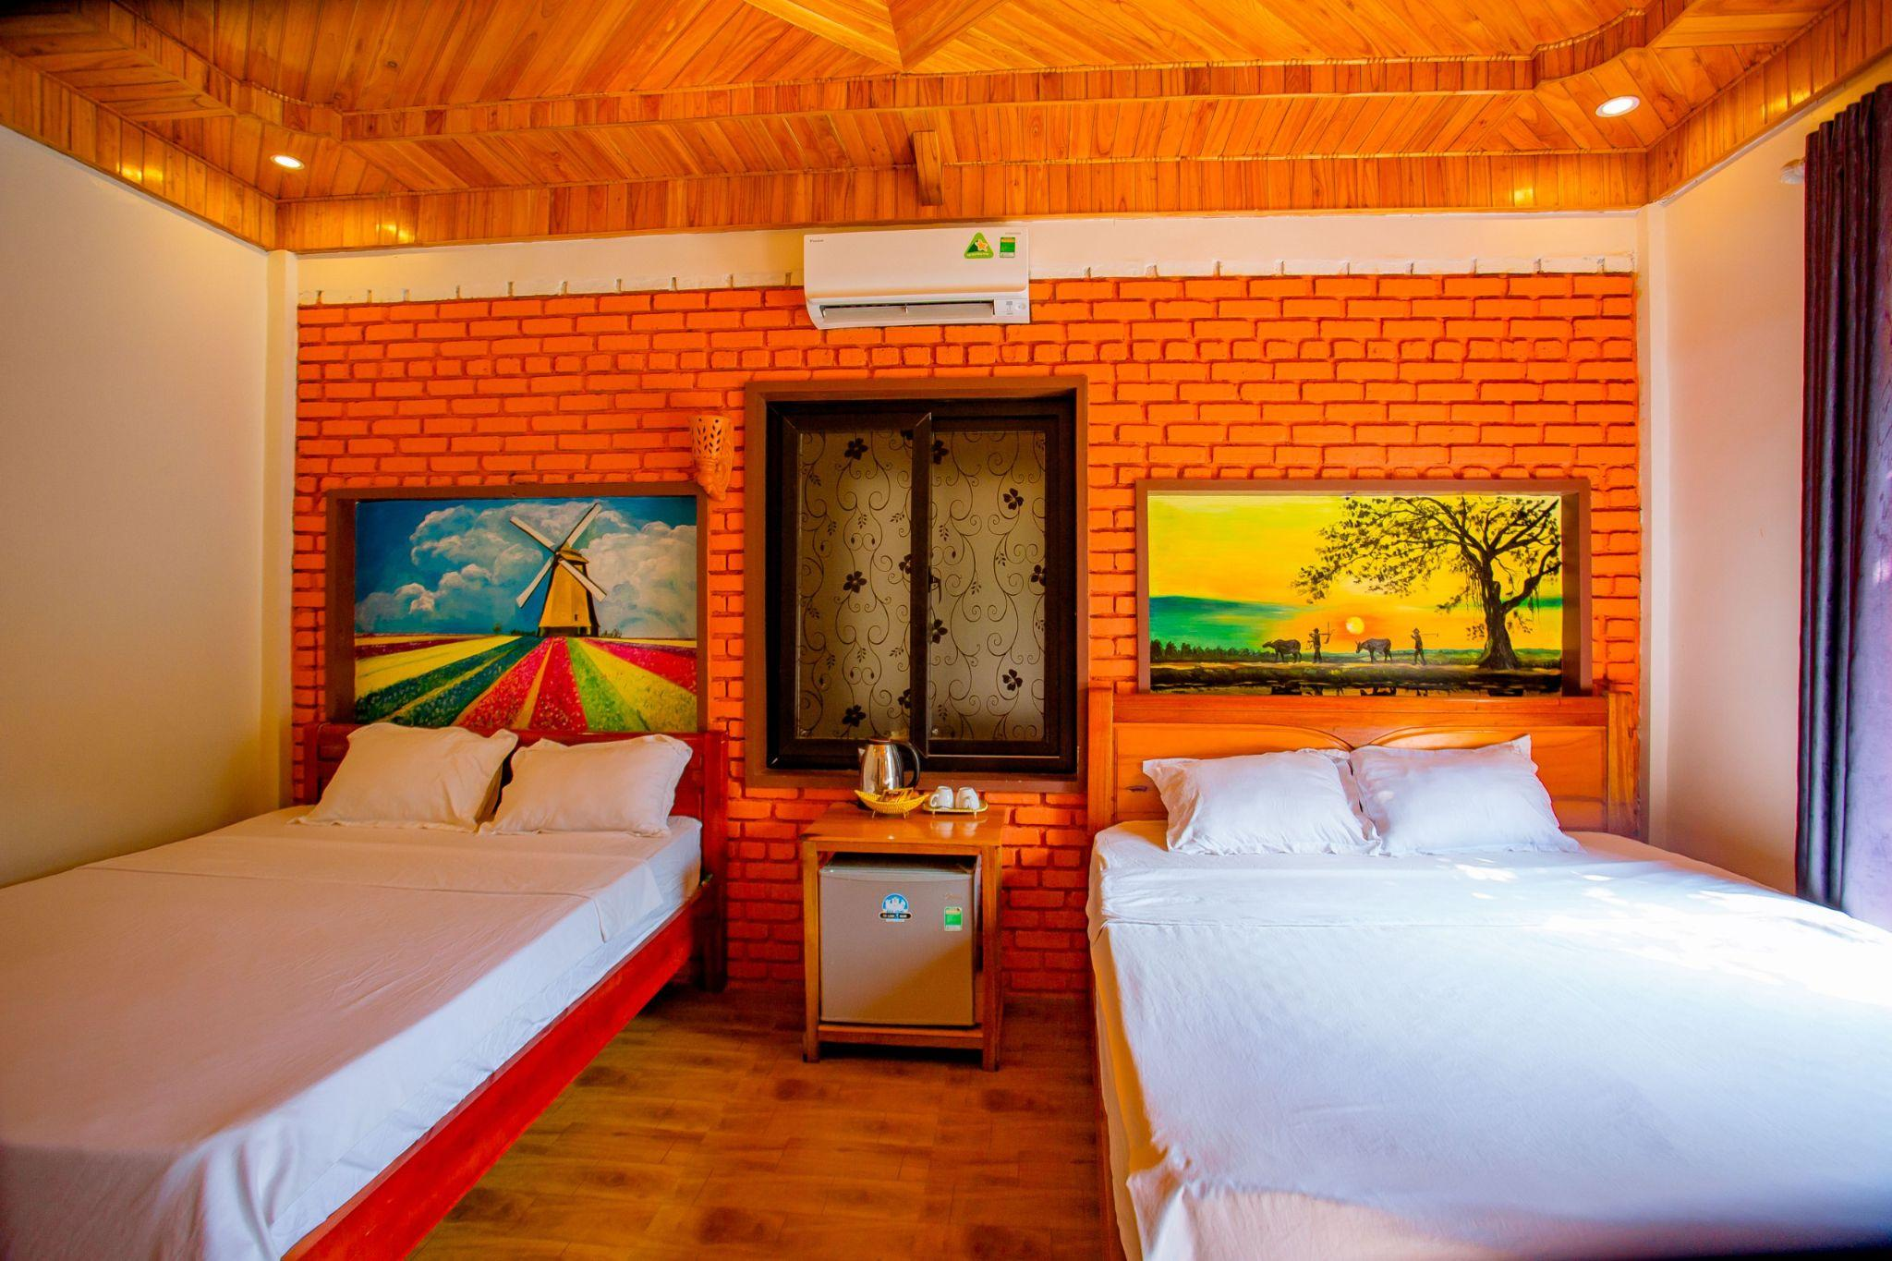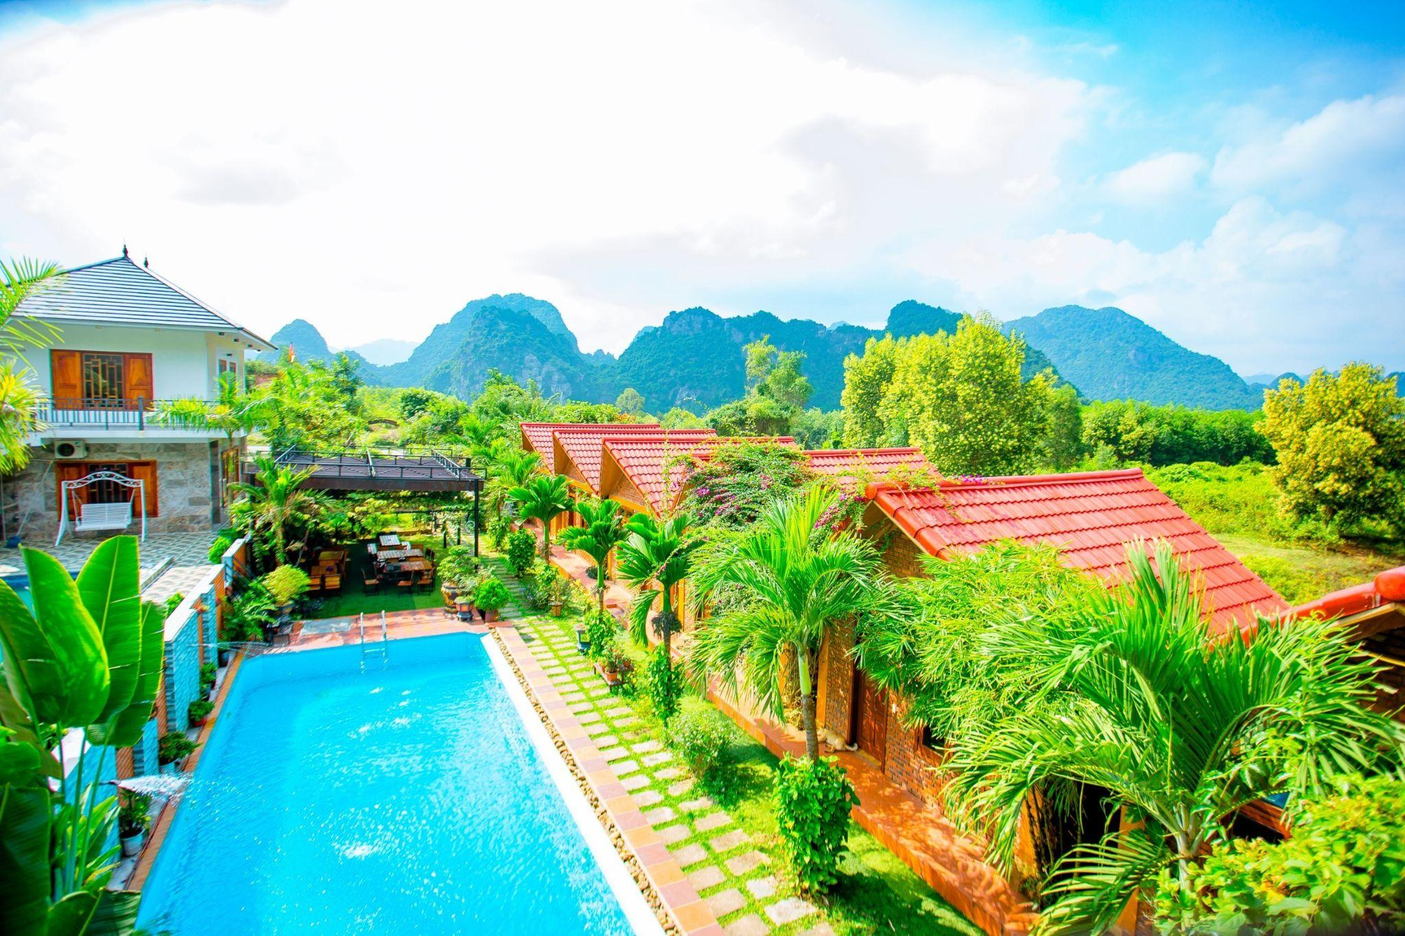
Where to stay: Hillside View Bungalow Homestay offers a warm, authentic Vietnamese welcome in a lush natural setting. With rustic-chic bungalows, a garden terrace, and river views, it’s an inviting place to recharge. The property also organizes tours and local experiences, making it easy for Boomers to dive into both adventure and culture while in Phong Nha.

Knysna, South Africa
Set along the heart of the country’s breathtaking Garden Route, Knysna is where lush forests meet turquoise lagoons, creating a haven for wildlife lovers. Baby Boomers can embark on a guided eco-kayak tour through the Knysna Estuary, spotting playful otters, colourful kingfishers and a variety of waterbirds in their natural habitat. During migration season, a whale-watching cruise offers the unforgettable sight of dolphins and Southern right and humpback whales in the open sea. Inland, forest trails provide opportunities to encounter indigenous birds, bushbucks and other native species, while local guides reveal the secrets of the region’s diverse ecosystems. Even culinary adventures connect with wildlife, Knysna’s world-famous oysters are harvested from the lagoon, a reminder of the rich life thriving beneath the waters. For a different kind of discovery, Boomers can explore nearby nature reserves and coastal habitats, experiencing South Africa’s wildlife up close while enjoying the thrill of being immersed in its untamed beauty.
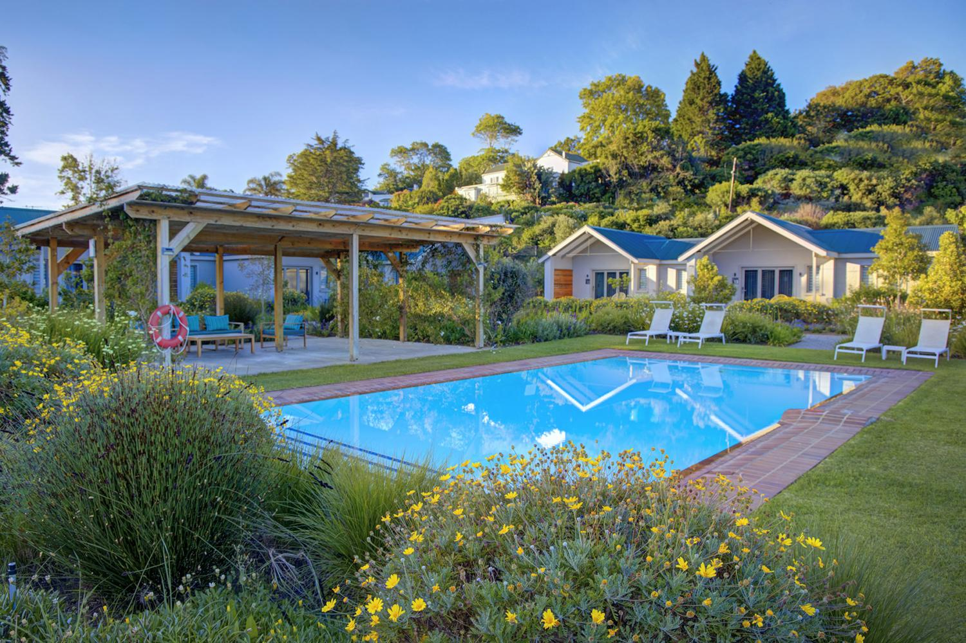
Where to stay: Knysna Hollow Country Estate provides a tranquil retreat surrounded by gardens and indigenous trees. With modern rooms, a sparkling pool, and a stylish restaurant serving South African-inspired dishes from bobotie (a spiced meat dish) to malva (a warm sponge pudding), it’s the perfect base for balancing outdoor adventure with comfort.

Bend, Oregon, USA
Tucked into Central Oregon’s high desert, Bend is the ultimate basecamp for Boomers eager to get out on the water for an adventure. Paddleboarding across serene alpine lakes provides visitors with a peaceful yet invigorating way to start the day, while kayaking along the Deschutes River combines gentle currents with occasional thrilling rapids. Anglers can cast for trout in crystal-clear streams, or join guided float trips to spot wildlife like herons and river otters along the banks. For those seeking something truly unique, the mile-long Lava River Cave offers underground pools that reflect Oregon’s volcanic past, blending exploration with a touch of mystery. Nearby reservoirs and waterways invite boating, sailing or even paddle yoga, while white-water rafting trips offer an adrenaline rush for those ready to take on bigger waves. With every bend of river and glint of sun on the lakes, Bend turns aquatic adventures into an experience that’s both exhilarating and rejuvenating.
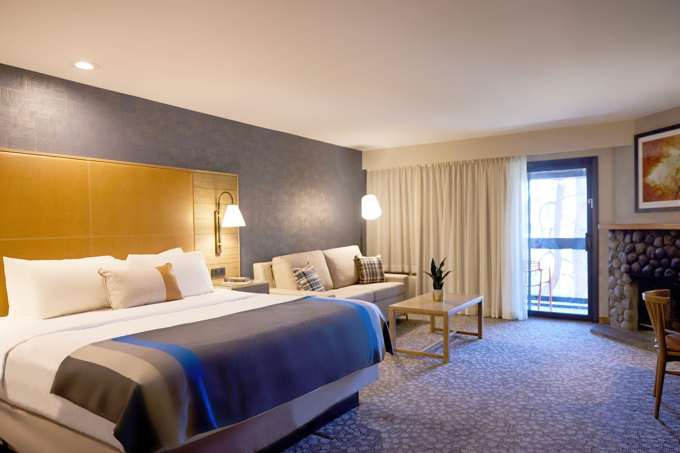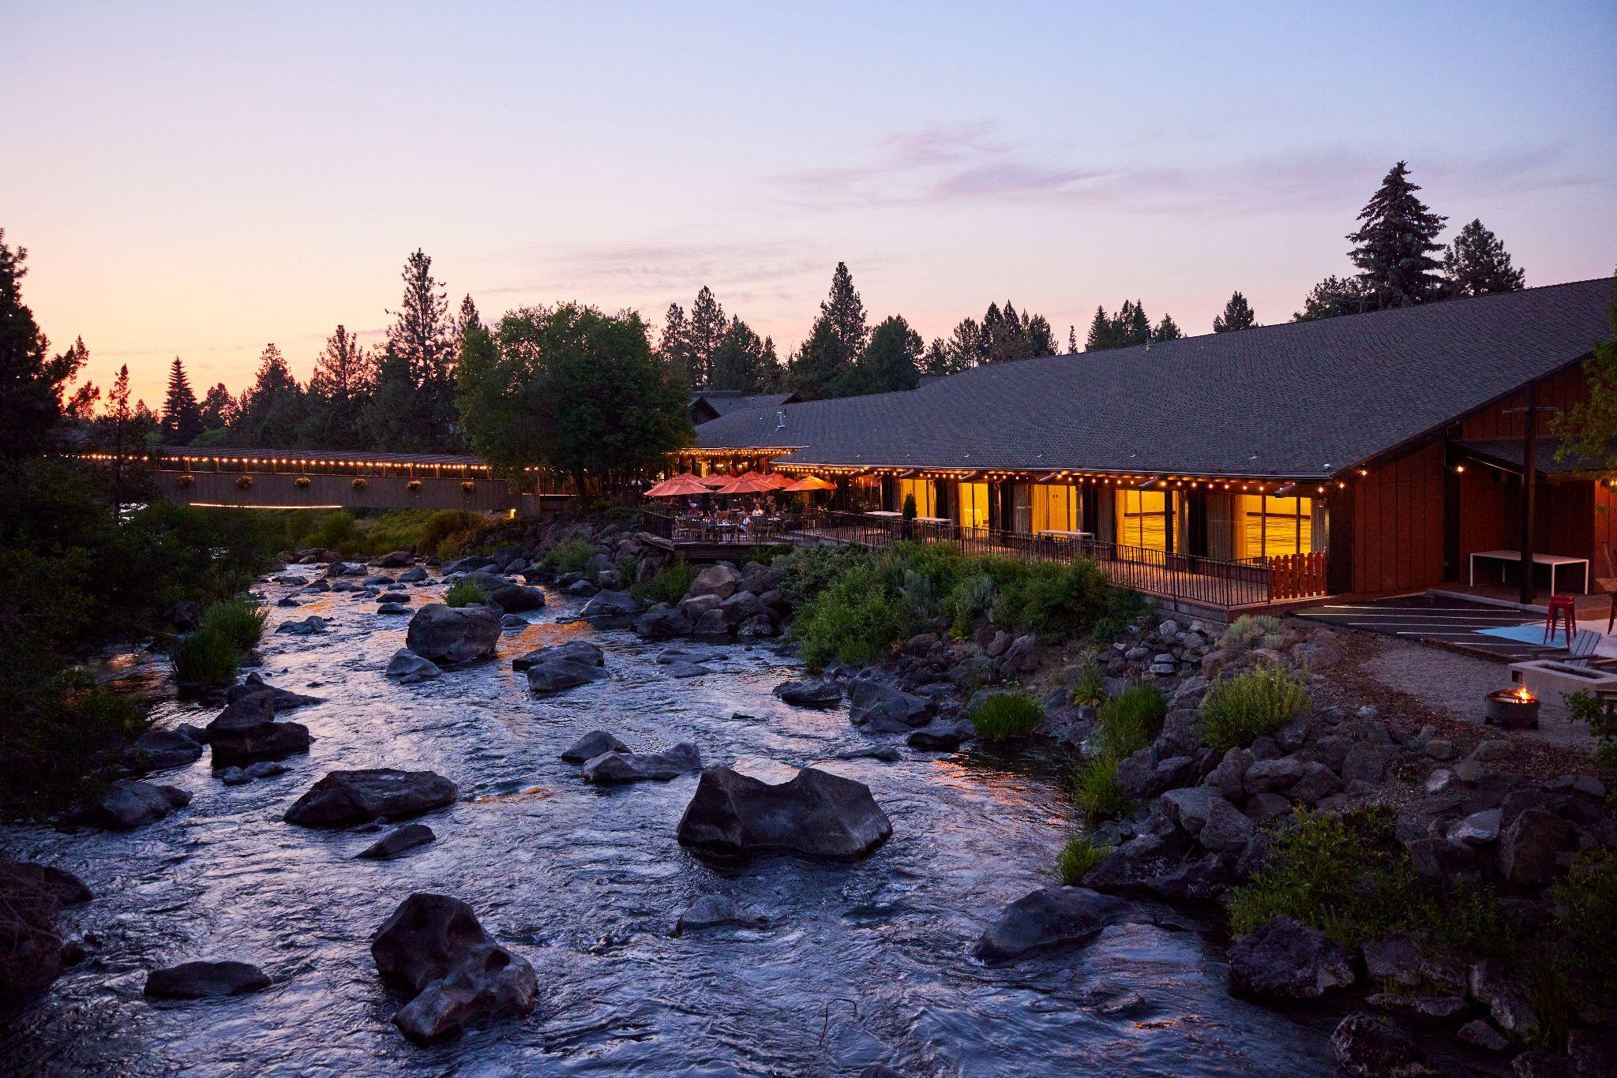
Where to stay: Riverhouse Lodge on the Deschutes blends the serenity of riverfront views with the convenience of being minutes from downtown Bend. Guests can relax by the indoor and outdoor pools, indulge in hearty Northwest cuisine at the onsite restaurant, and recharge in spacious rooms that overlook the rushing Deschutes River.

Kotor Bay, Montenegro
Framed by sheer cliffs plunging into sapphire waters, the fjord-like Bay of Kotor is a playground for explorers keen to set off an adventurous hike. Boomers can tackle the 1,350 steps to San Giovanni Fortress, rewarded with sweeping views of the Adriatic’s only fjord and centuries of history etched into its walls. Travelers can embark on a walking tour through Lovćen National Park revealing rugged mountains and panoramic vistas steeped in the cultural heritage Kotor’s UNESCO-listed Old Town. Cycling the old Austro-Hungarian military roads offers insight into Montenegro’s past, while centuries-old monasteries and surrounding towns provide further historical glimpses. Evening strolls reveal Kotor’s timeless architecture and bustling markets, while traditional music echoes through the medieval squares, bringing the streets to life. Each step through the city and surrounding trails connects travelers with centuries of history, leaving a lasting impression where every corner tells a story and every path invites your next exploration.

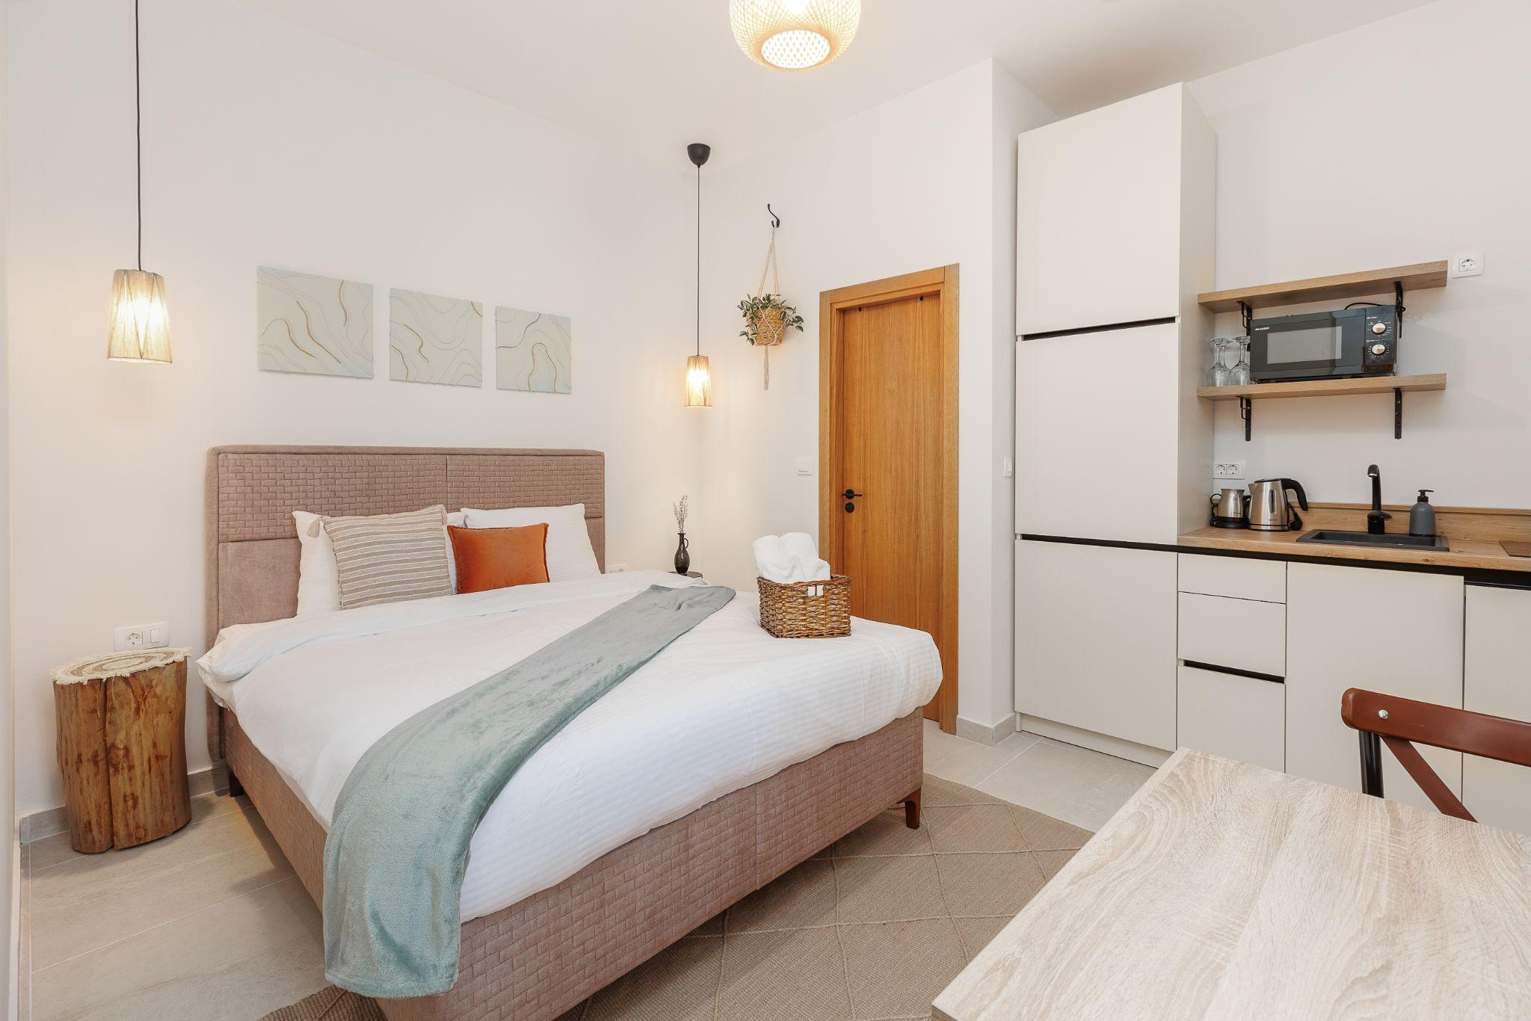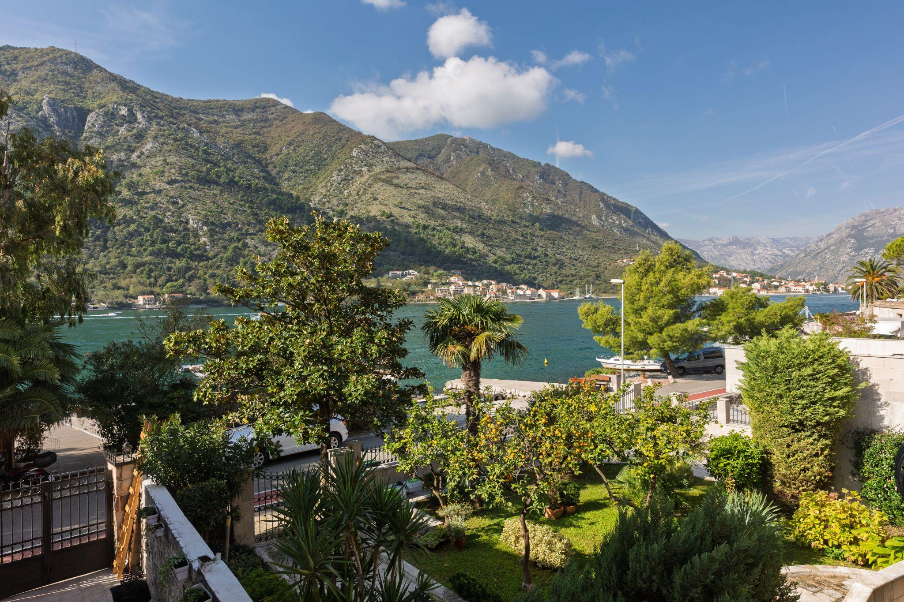
Where to stay: The waterfront apartments of VerDi put guests right at the edge of the bay, offering serene views, direct access to the water and accommodation within one of the city’s historic buildings. Spacious and modern interiors create a comfortable home base, while private balconies make for perfect sunset-watching after a day of exploration.

Mendoza, Argentina
Adventure meets indulgence in Mendoza, where the towering Andes provides the perfect playground for active Boomers. Horseback riding through the Andean foothills with local gauchos, enables travelers to feel the thrill of the mountains up close. For adrenaline seekers, guided 4x4 excursions deep into Aconcagua Provincial Park offer rugged terrain and breathtaking views of South America’s highest peak or even paragliding over Mendoza’s valleys to give visitors a rush from above. Winter transforms the region into a skiers’ paradise at Las Leñas, whilst summer invites hiking and mountain biking along scenic trails. The Hot Springs at Cacheuta provides a restorative reward after an exhausting day, filled with thrilling activities. Mendoza proves that exploration isn’t just for the young, every activity engages the body, ignites the senses and fuels the spirit.

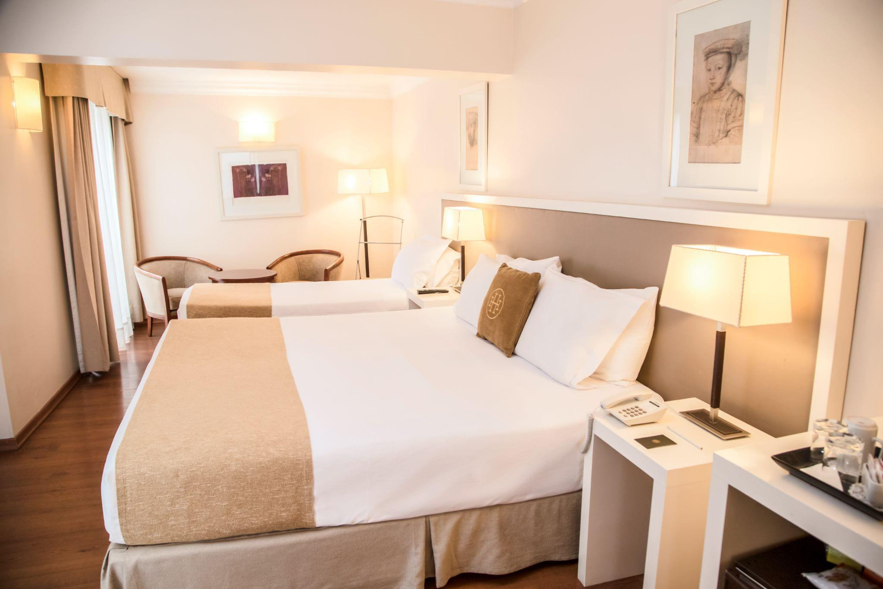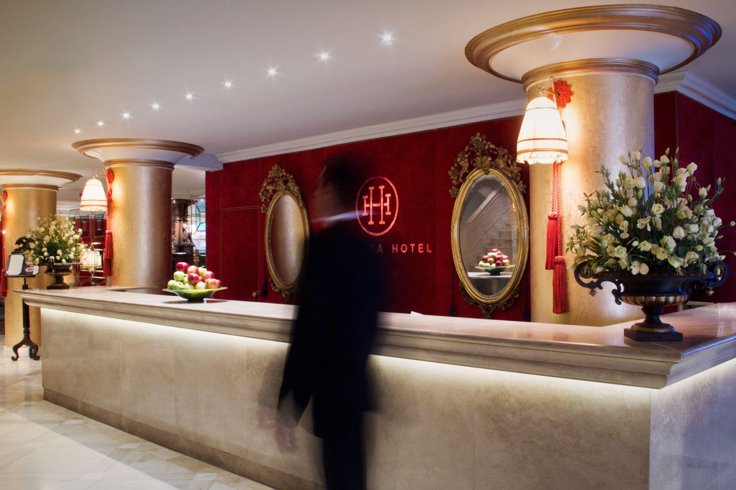
Where to stay: Huentala Hotel is a stylish and comfortable retreat for travelers seeking both adventure and relaxation. With elegant rooms, a refreshing pool and an art gallery, it’s the ideal place to recuperate after a busy day of exploring. Conveniently located near the city centre, Boomers can wander into town before heading home for a night of much-needed rest.

*Travel Predictions 2025 research commissioned by Booking.com and conducted among a sample of adults who plan to travel for business or leisure in the next 12-24 months. In total, 27,713 respondents across 33 countries and territories were polled (including 1,016 from Argentina, 1,002 from Australia, 502 from Austria, 1,003 from Belgium, 1002 from Brazil, 1,006 from Canada, 1,007 from China, 1,005 from Colombia, 501 from Croatia, 501 from Denmark, 1,011 from France, 1,009 from Germany, 1,004 from Hong Kong, 1,002 from India, 506 from Ireland, 501 from Israel, 1,014 from Italy, 1008 from Japan, 1,013 from Mexico, 1011 from The Netherlands, 1003 from New Zealand, 504 from Portugal, 508 from Singapore, 1,004 from South Korea, 1,008 from Spain, 509 from Sweden, 500 from Switzerland, 507 from Taiwan, 1,009 from Thailand, 503 from the UAE, 1,012 from the UK, 1,006 from the US and 1,016 from Vietnam). Respondents completed an online survey in July-August 2024.

